**CST8256 Web Programming Language I**

Lab 3

# Objective

1. Understand and use C# lambda expression
2. Understand and use C# delegate and event model
3. Use class library
4. Use ASP.NET Master Page
5. Dynamically add elements to Master Page and bind event handlers to controls.

# Due Date

See Brightspace posting for the due date. To earn 5 points, you are required:

1. Complete the lab as required.
2. Zip your **website** into a zip file and submit the zip file to the Canvas.
3. Demonstrate your lab work during the following week’s lab session.

# Requirements

1. Download and unzip “Lab3.zip” file. You will get a partially completed website for

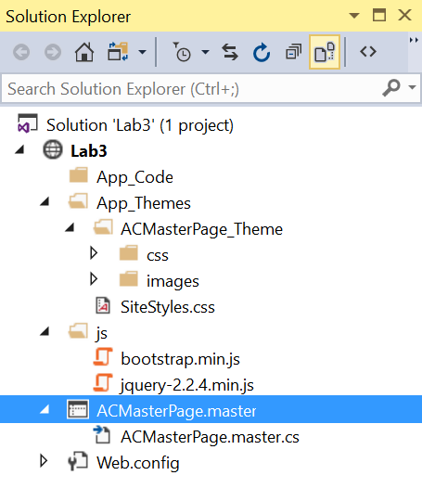

Study the included **ACMasterPage.master**. All your pages should use this master page so that they have common look-and-feel. You cannot modify any part of this master page since a master page is commonly shared by all web pages of an organization. Instead, you need dynamically modify the controls on the master page in your code to suit the needs of your web applications.

Specifically, pay attention to the following section in the master page:

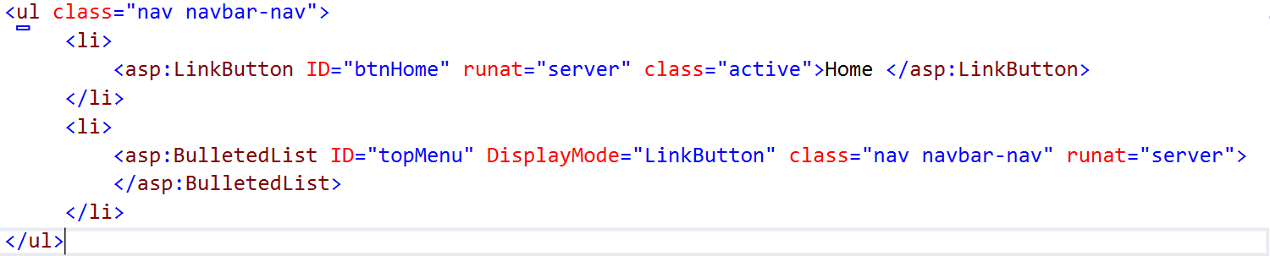

* You will need to attach the event handler to LinkButton btnHome so that when it is clicked, the user is brought back to the home page, that is, Default.aspx page.
* You will need to add items to BulletedList to show more top menu items pertain to each page’s navigation, see below.

1. Download and unzip Lab3Resources.zip file. It gives you a class library, **AlgonquinCollegeEntities.dll**, containing the entity classes you need for this lab:

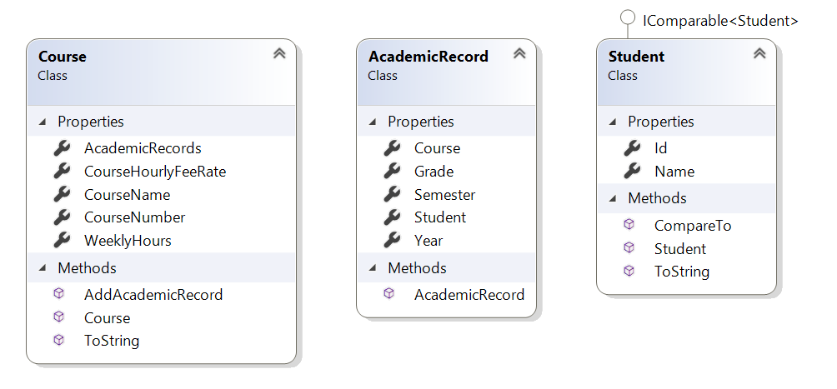

* To use this class library, you need add a reference to it in your website as follows:

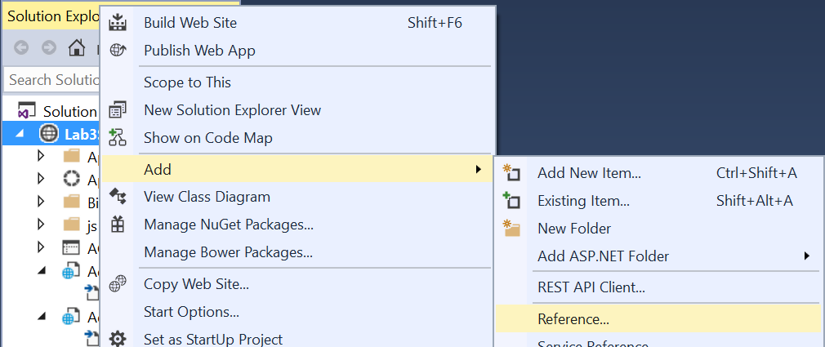

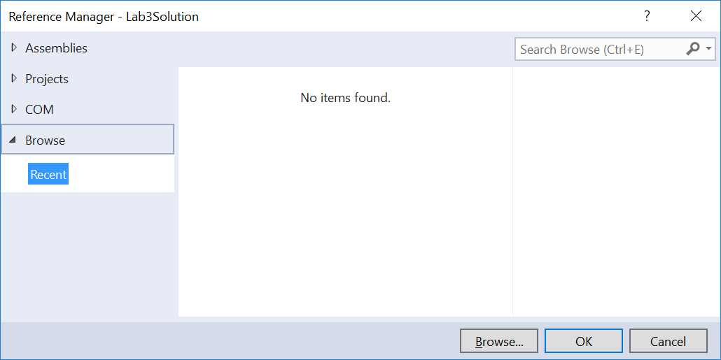

After adding the reference to this class library, your website should have a new **bin** folder as

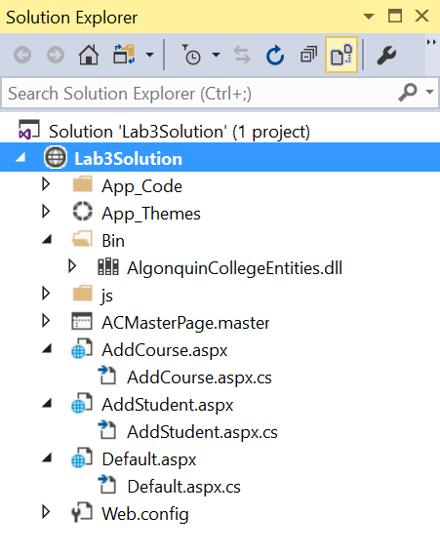

* You can browse the contents of the class library using Visual Studio’s **Object Browser** (if you do not see it, select menu item View > Object Browser)

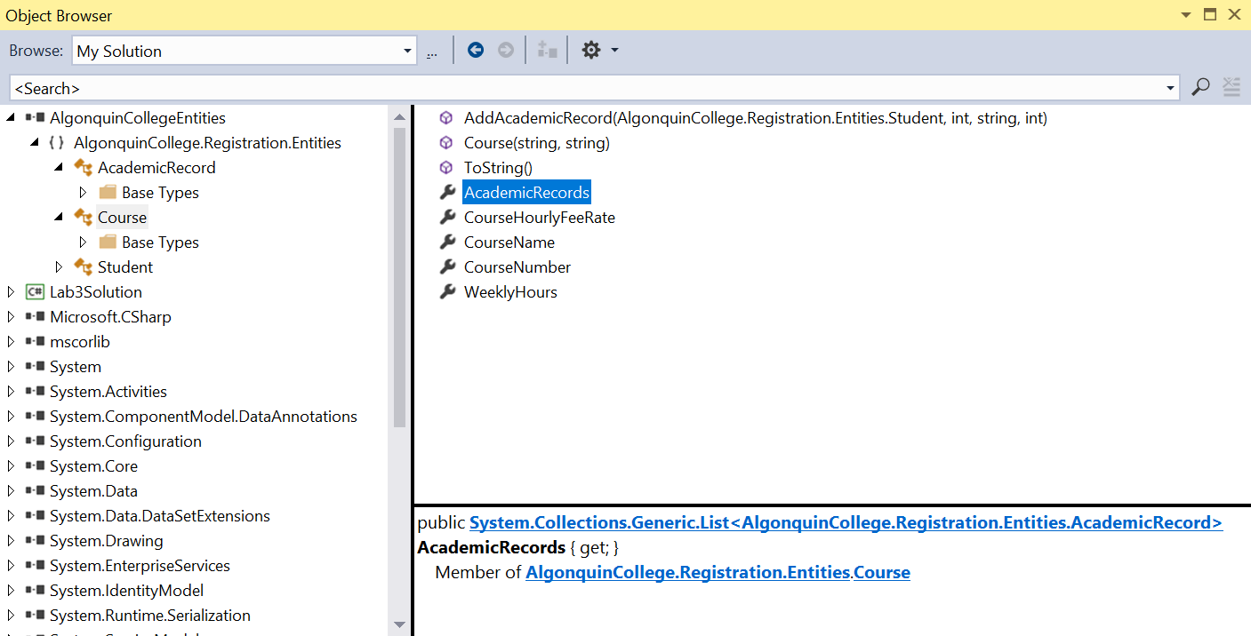

* As you can see, the classes defined in this class library are in namespace **AlgonquinCollege.Registration.Entities**. To use these classes, you must put the following statement at the top of the file:

using AlgonquinCollege.Registration.Entities;

1. Your website should have 3 aspx pages:

* **Default.aspx** – This is the landing page (a.k.a. home page) of your website. By default, if a request to an ASP.NET website, with a URL without specifying a page, the ASP.NET will server Default.aspx (if exists) to the client.

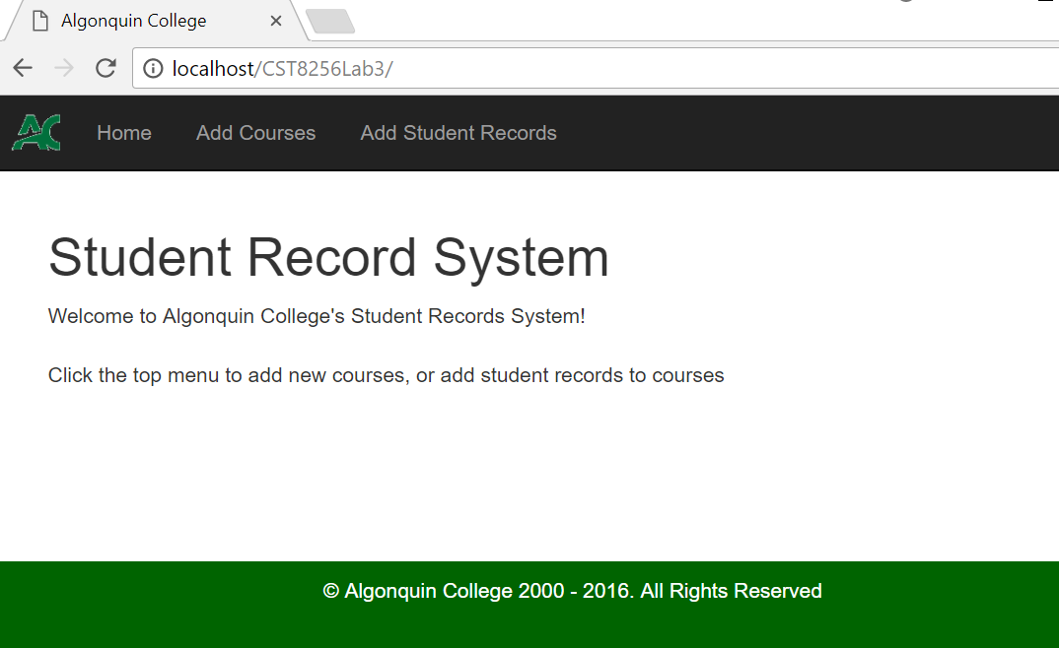

The top menu of the page should have the following links:

* **Home** – this link button leads the user to the home page of this website. Since this is the home page of the website, you should disable this link.
* **Add Courses** – this link button leads the user to **AddCourse.aspx** page.
* **Add Student Records** – this link button leads the user to AddStudent.aspx page.

**Hint**:

* Since all event handlings simply redirect the user to a page, they are best implemented using **lambda** expressions and bound to the link buttons in the code behind of Default.aspx page.
* **AddCourse.aspx** – On this page allows users to add new courses to the system.

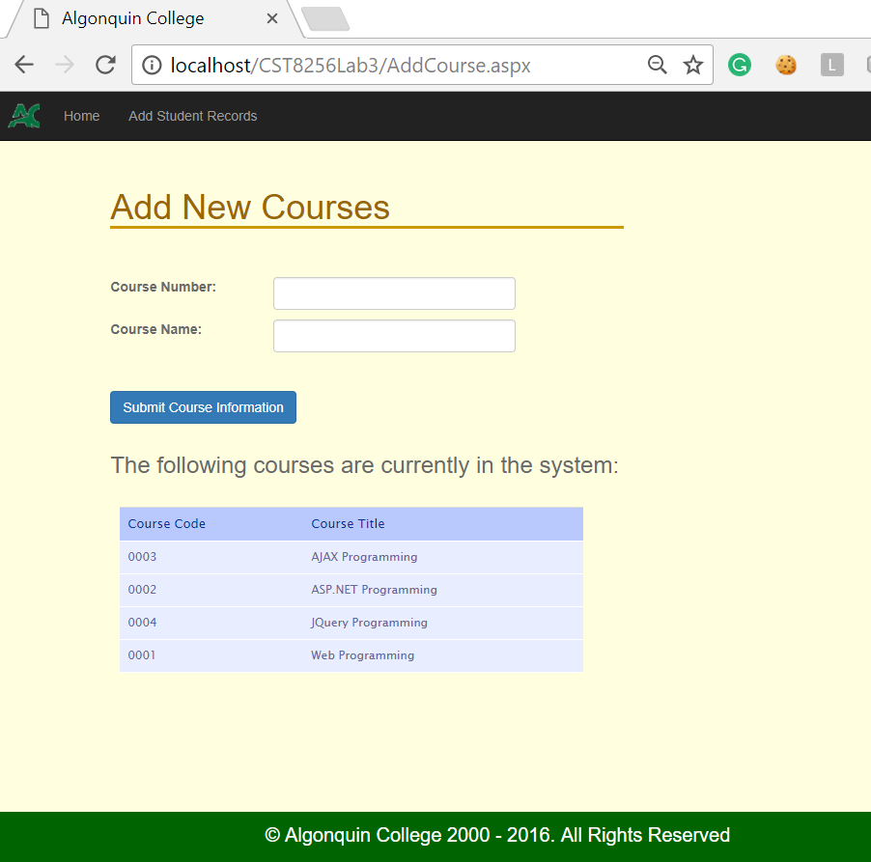

The top menu of the page should have the following links:

* **Home** – this link leads the user to the home page of this website, that is, Default.aspx page.
* **Add Student Records** – this link leads the user to AddStudent.aspx page.

You should use lambda expressions to implement all event handlers and bind them to the link buttons in the code behind of Default.aspx page.

* The column headers of the course table should be clickable. The user can click a column’s head to sort the courses by the clicked column.
* Click the same column the second time will reverse the sorting order from ascending to descending or vice versa.

**Hints**:

* Besides using forms to pass data to from client to server, another common way of passing data to a server is to use URL query string to pass data to server, for example:



To retrieve the values passed via query string at the server. You can use the Response’s Params property which is key-value-pair associative array as follows:

string sort = Request.Params["sort"];

* Since the sorting are simple, you should use lambda expressions to specify the sorting function.
* **AddStudent.aspx** – The page let the user add new student record to a selected course. It also displays the student records already added to the course.

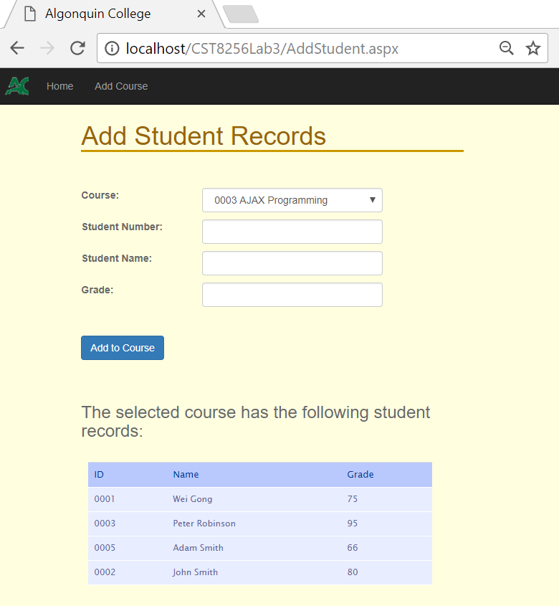

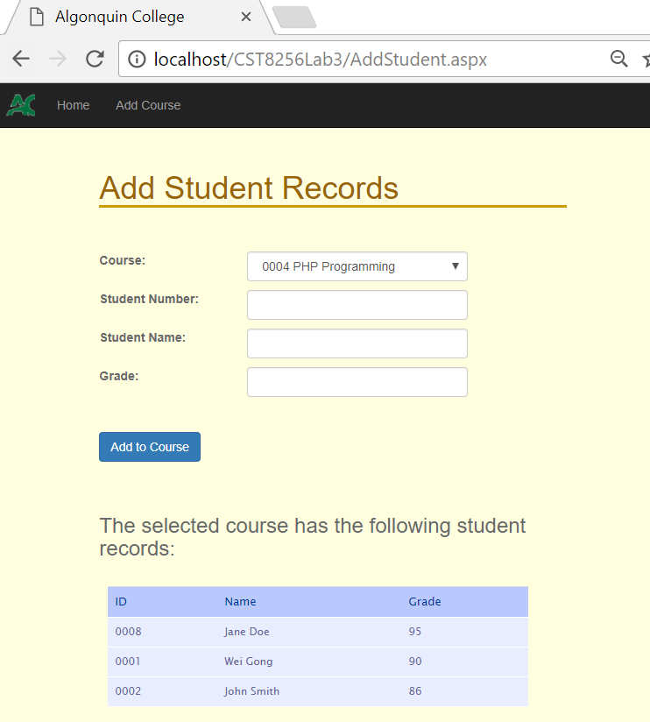

The top menu of the page should have the following links:

* **Home** – this link button leads the user to the home page of this website, that is, **Default.aspx** page
* **Add Courses** – this link button leads the user to **AddCourse.aspx** page.

The students in display should be sorted by last name and then first name. For simplicity, you are not required to make table column headers clickable.

Hint:

* Reuse the Comparer class you created in Lab 2.
* You should use lambda expressions to specify the sorting function.